1. Create an html page to display the following nested list  
   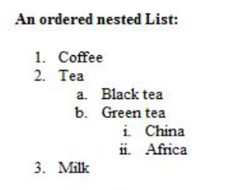

**Code:**

<html>

<head>

</head>

<body>

<b>An ordered nested List:</b>

<ol>

<li>Coffee</li>

<li>Tea</li>

<ol Type="a">

<li>Black tea</li>

<li>Green tea</li>

<ol Type="i">

<li>China</li>

<li>Africa</li>

</ol>

</ol>

<li>Milk</li>

</body>

</html>

**Output :**

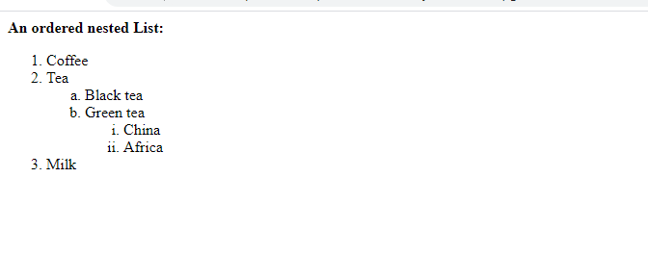

1. Create links to three different pages on three different websites that should all open in a new window.

**Code:**

<html>

<head>

<title>Links to various pages</title>

</head>

<body>

<a href="http://www.facebook.com/about.php" target="_blank">facebook.com </a>

<br><br>

<a href="https://psc.kerala.gov.in/kpsc/" target="_blank">Kerala Public Service Commission </a>

<br><br>

<a href="http://web.sjcetpalai.ac.in" target="_blank">web.sjcetpalai.ac.in </a>

<br><br>

</body>

</html>

**Output:**

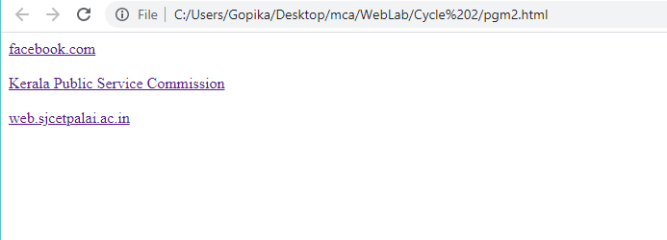



1. Create a page with a link at the top of it that when clicked will jump all the way to the bottom of the page.

**Code:**

<html>

<head>

</head>

<body>

<a href="#bottom">Click here to jump to the bottom of the page</a>

<br>

One<br>

Two<br>

Three<br>

Four<br>

Five<br>

Six<br>

Seven<br>

Eight<br>

Nine<br>

Ten<br>

One<br>

Two<br>

Three<br>

Four<br>

Five<br>

Six<br>

Seven<br>

Eight<br>

Nine<br>

Ten<br>

One<br>

Two<br>

Three<br>

Four<br>

Five<br>

Six<br>

Seven<br>

Eight<br>

Nine<br>

Ten<br>

One<br>

Two<br>

Three<br>

Four<br>

Five<br>

Six<br>

Seven<br>

Eight<br>

Nine<br>

Ten<br>

One<br>

Two<br>

Three<br>

Four<br>

Five<br>

Six<br>

Seven<br>

Eight<br>

Nine<br>

Ten<br>

One<br>

Two<br>

Three<br>

Four<br>

Five<br>

Six<br>

Seven<br>

Eight<br>

Nine<br>

Ten<br>

<a name="bottom">The bottom of the page</a>

</body>

</html>

**Output:**

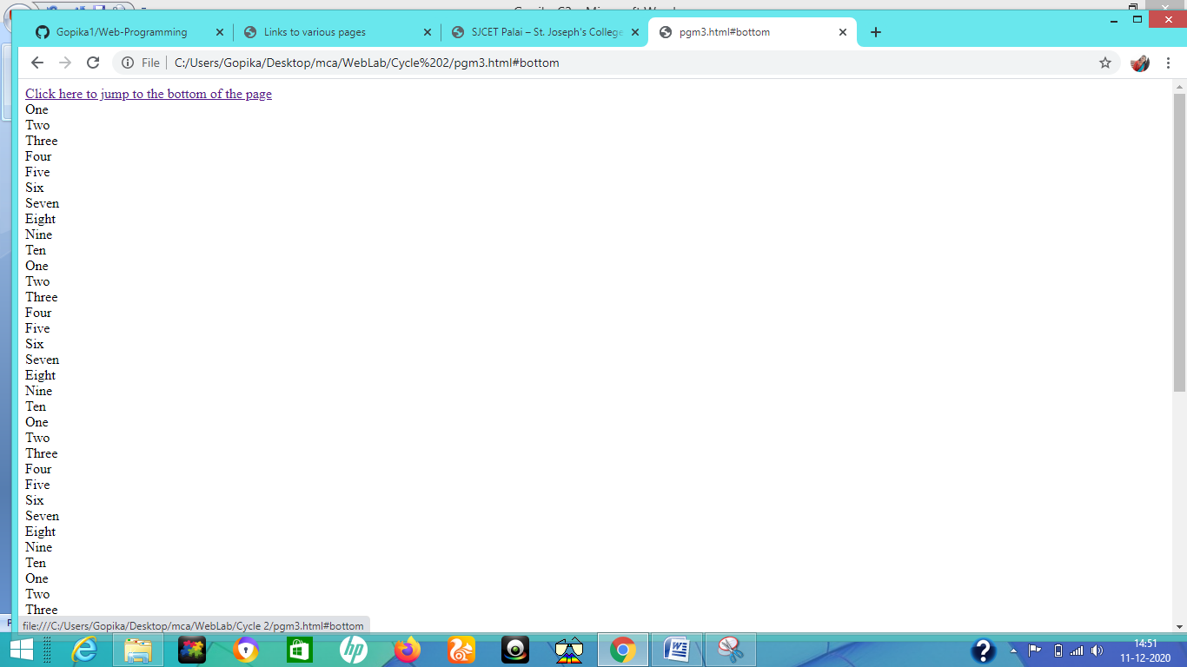

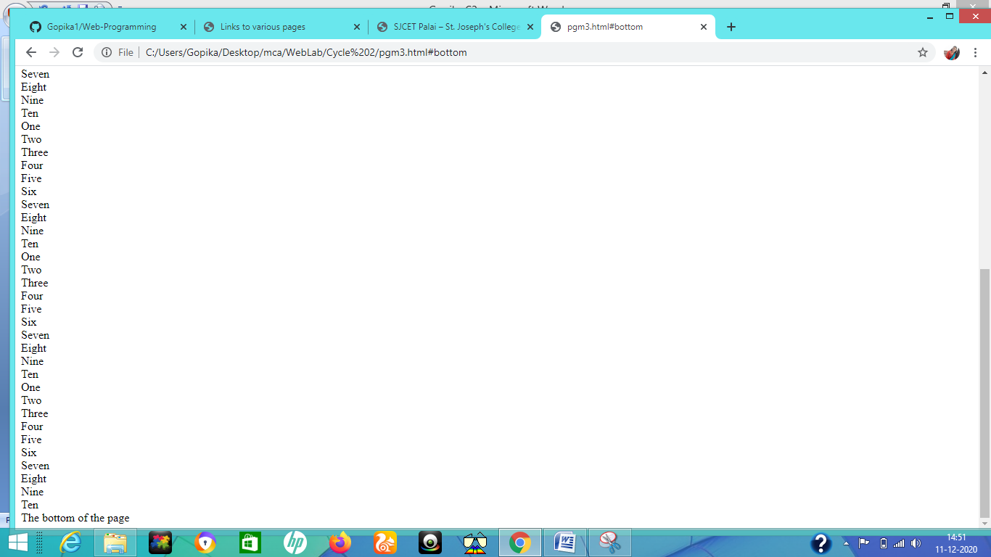

1. Display three different images. Skip two lines between each image. Each image should have a heading.

**Code:**

<html>

<head>

</head>

<body>

<br><br>

<img src="bird.jpg" alt="bird" title="Bird"/>

<br><br>

<img src="Cat.jpg" alt="Cat" title="Cat"/>

<br><br>

<img src="flower.jpg" alt="flower" title="Flower"/>

</body>

</html>

**Output:**

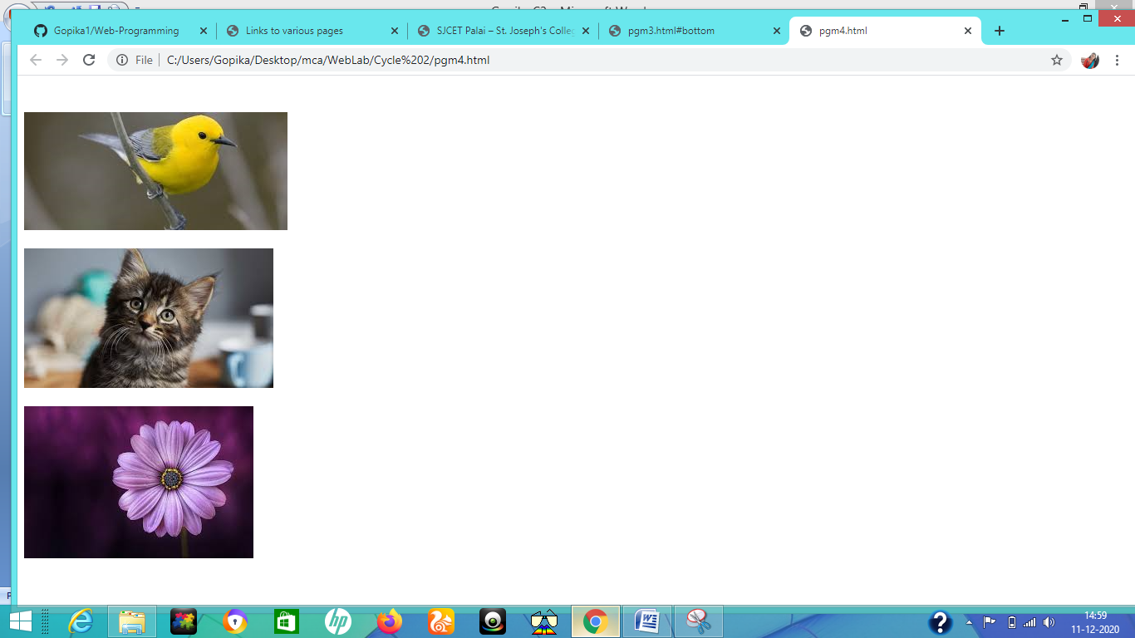

1. Display an image that when clicked will link to a search engine of your choice in a different window

**Code:**

<html>

<head>

</head>

<body>

<br><br>

<center>

<a href="https://www.google.com/" target="_blank">

<img src="google.jpg" alt="GOOGLE"

</a>

<p>Click on the image to be taken to the Google search engine.</p>

</center>

</body>

</html>

**Output:**

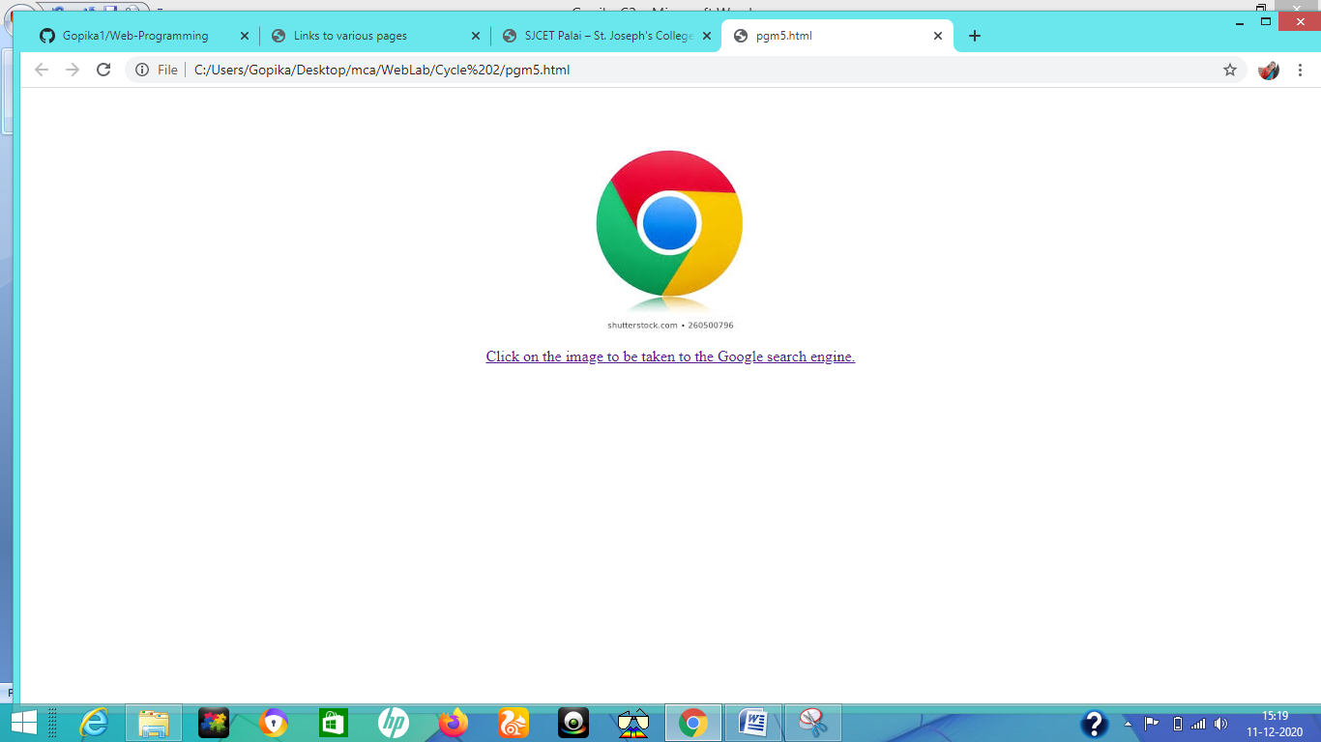

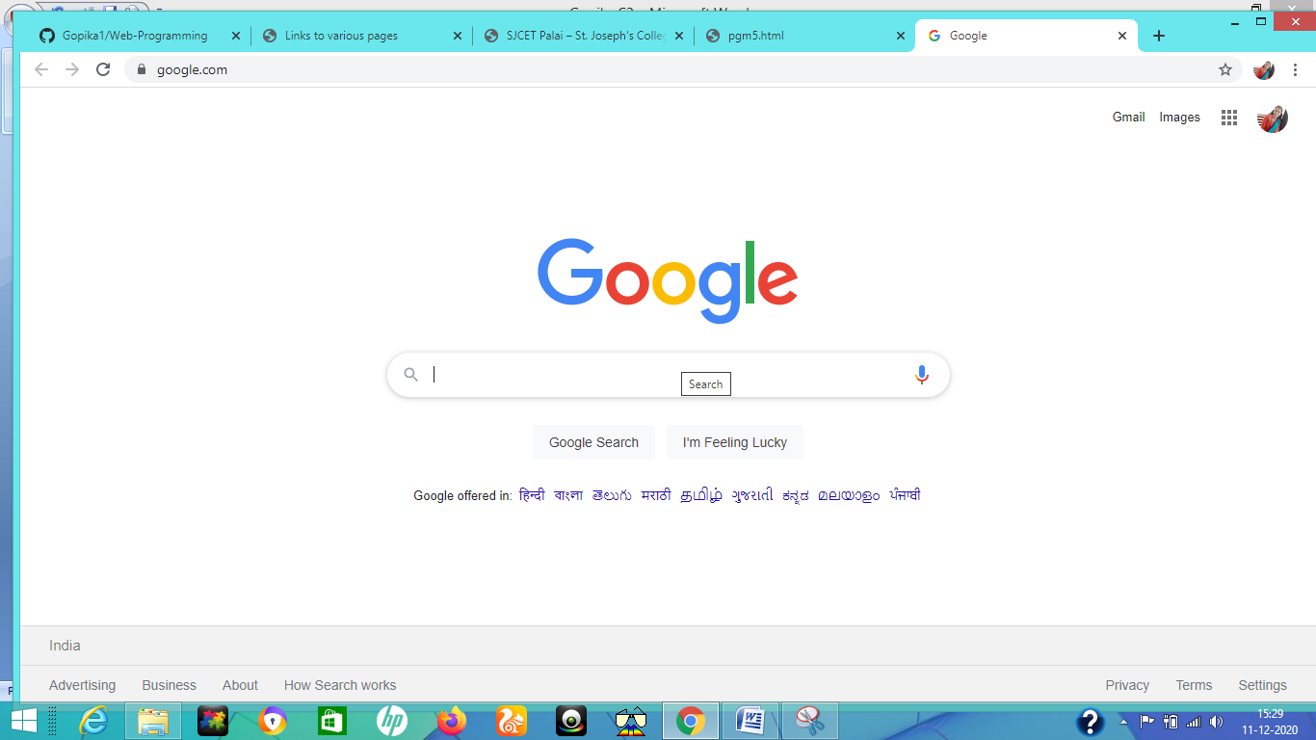

1. Create the following Html Page using appropriate form controls

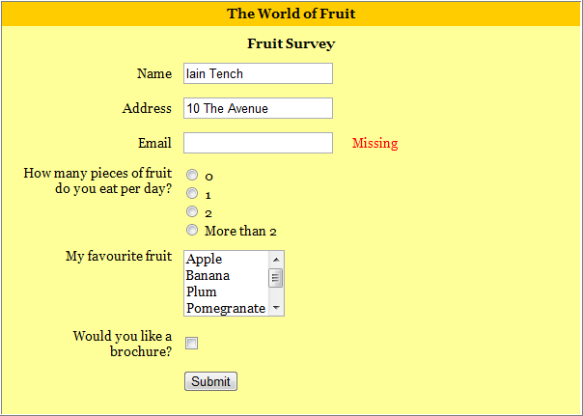

**Code:**

<html>

<head>

<style>

.div_1{background-color:orange;margin:20px;}

.div_2{background-color:yellow;margin:20px;}

</style>

</head>

<body>

<center>

<div class="div_1"><font size="4" face="Cooper"><hl>The World of Fruit</hl></font></div>

<div class="div_2">

<form method="post">

<font size="4" face="Cooper"><hl align="center">Fruit Survey</hl></font>

<table align="center">

<tr>

<th>Name</th>

<td><input type="text" name="name" style="width:400px;" class="form-control" required=""></td>

</tr>

<tr>

<th>Address</th>

<td><input type="text" name="address" style="width:400px;" class="form-control" required=""></td>

</tr>

<tr>

<th>Email</th>

<td><input type="text" name="Email" style="width:400px;" class="form-control" required=""></td>

</tr>

<tr>

<th>How many pieces of fruit<br>do you eat per day?</th>

<td><input type="radio" name="0" value="0">0<br><input type="radio" name="1" value="1">1<br><input type="radio" name="2" value="2">2<br><input type="radio" name="More than 2" value="More than 2">More than 2

</tr>

<tr>

<th>My Favorite fruit</th>

<td><textarea rows="4" cols="12" name="favorite fruit" style="overflow-y: scroll;">Apple Banana Plum Pomegranate Orange </textarea>

</td>

</tr>

<tr>

<th>Would you like a<br>brochure?</th>

<td><input type="checkbox" name="yes" value="on"></td>

</tr>

<tr>

<td align="center" colspan="2"><input type="submit" name="submit" value="submit"></td>

</tr>

</table>

</form>

</div>

</center>

</body>

<html>

**Output:**

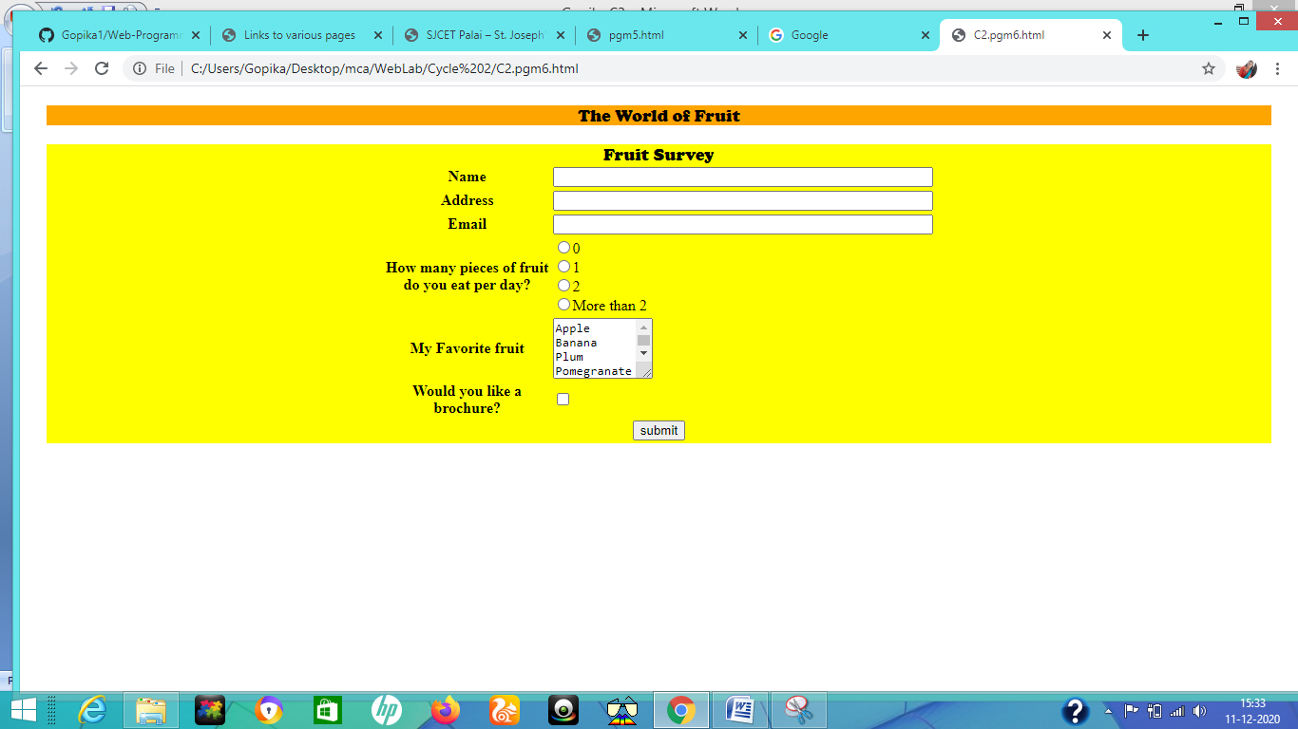

1. Create an image map for ‘Kerala Map’. Map at least 3 districts so that when you click on that particular district the details regarding that district(**eg: population, Area, Tourist Spots(with images), Monuments, Interesting Facts )** should be displayed on a new page.

**Code:**

<html>

<head>

</head>

<body>

<center>

<h1><u><font color="grey" face="Cooper">KERALA MAP</font></u></h1>

<map name="Kerala">

<area shape="circle" coords="345,481,40" href="Kottayam.html"/>

<area shape="circle" coords="400,525,40" href="Pathanamthitta.html"/>

<area shape="circle" coords="277,169,40" href="wayanad.html"/>

</map>

<img src="Kerala.jpeg" alt="kerala" usemap="#Kerala"/>

</center>

</body>

</html>

**Kottayam.html**

<html>

<head>

<style>

.div_1{ background-color:red; margin:20px; }

.div_2{ background-color:yellow; margin:20px; }

</style>

</head>

<body>

<center>

<br>

<div class="div_1"><h1><font color="white" size="6" face="Cooper">KOTTAYAM</font></h1></div>

<div class="div_2"><font color="green" face="Comic sans MS">

<p>Kottayam is a district in the Indian state of Kerala. Kottayam literally means the interior of a fort—Kotta + Akam. Flanked by the Western Ghats on the east and the Vembanad Lake and paddy fields of Kuttanad on the west, Kottayam is a place that is known for extraordinary qualities.</p>

<h1><u>POPULATION</u></h1>

<p>As of 2001 India census,[13] Kottayam Urban Agglomeration had a population of 172,878, while Kottayam district had a population of 1,974,551. The population of Kottayam municipality was 136,812. Males constituted 62% of the population and females 38%. Population growth in the district had a diminishing trend with a decadal population growth rate of 6.5% compared to 9.35% across the decade 1991–2000.[14] Population growth in the municipality is due to migration for employment.</p>

<h1><u>AREA</u></h1>

<p>77.8km<sup>2</sup></p>

<h1><u>TOURIST SPOTS</u></h1>

<h2>ILLIKKAL KALLU</h2>

<img src="Illikkal.jpg" alt="illikkal kallu" height="260" width="525"/>

<p>Located at a height of 6000 ft above the sea level in the Western Ghats of Kottayam, Kerala, Illikkal Kallu is a major tourist attraction and one of the most pristine spots in all of India. Situated in Moonnilavu Village, Meenachil taluk, the nearest city to the summit is Teekoy.</p>

<h2>MARMALA WATERFALLS</h2>

<img src="marmala.jpg" alt="maramala" height="260" width="525"/>

<p>Located at a distance of few kms from Erattupetta in Kottayam inside a private rubber estate, Marmala Waterfalls are popularly known as the ‘enchantress of the jungle’. Plummeting from a height of 200 feet, the unblemished clear waters create and aura of mist around them.</p>

<h2>KOTTATHAVALAM</h2>

<img src="kottathavalam.jpg" alt="kottathavalam" height="260" width="525"/>

<p>A fascinating cave carved out of rock surface is Kottathavalam lying on the top of a Murugan Hills at Kurisumala. The cave is considered to be the resting place for Madura Royal family

<h2>MONUMENTS</h2>

<p><b>Bhrananganam</b>:The Church here is another Important pilgrim center in kerala.The mortal remains of the Saint Sr.Alphonsa is laid to rest here.</p>

<br>

</div>

</body>

</html>

**Pathanamthitta.html**

<html>

<head>

<style>

.div_1{ background-color:red; margin:20px; }

.div_2{ background-color:yellow; margin:20px; }

</style>

</head>

<body>

<center>

<br>

<div class="div_1"><h1><font color="white" size="6" face="Cooper">PATHANAMTHITTA</font></h1></div>

<div class="div_2"><font color="green" face="Comic sans MS">

<p>Pathanamthitta is a municipality situated in the Central Travancore region in the state of Kerala, India.Under the three tier system of panchayat in rural areas, Pathanamthitta has one district panchayat, 8 block panchayat and 53 grama panchayats.</p>

<h1><u>POPULATION</u></h1>

<p> According to the 2011 census Pathanamthitta district has a population of 1,195,537. This gives it a ranking of 399th in India .</p>

<h1><u>AREA</u></h1>

<p>2,642 km<sup>2</sup></p>

<h1><u>TOURIST SPOTS</u></h1>

<h2>Thrikkakkudi Rock-Cut Temple - Kaviyoor</h2>

<img src="Thrikkakkudi Rock-Cut Temple.jpg" alt="Thrikkakkudi Rock-Cut Temple" height="260" width="525"/>

<p>At a distance of 29 Kms from Pathanamthitta & 6 Kms from Thiruvalla, Trikkukkudi Rock-Cut Temple located near Kaviyoor is an 8th century Rock-Cut temple built in Pallava style of architecture and a place of great archeological importance.</p>

<h2>PERUNTHENARUVI WATERFALLS</h2>

<img src="Perunthenaruvi.jpg" alt="Perunthenaruvi" height="260" width="525"/>

<p>At a distance of 26 Kms from Pathanamthitta, Perunthenaruvi Waterfalls is a wonderful waterfall formed on Pampa River. It is one of the best waterfall to visit as part of Kerala tour packages and a famous tourist attraction in Pathanamthitta district.</p>

<h2>GAVI</h2>

<img src="Gavi.jpg" alt="Gavi" height="260" width="525"/>

<p>One of the most beautiful places in India, Gavi is a small village tucked between tea estates and wide and dense forests. A unique project in itself, the place is a model of eco-tourism site bringing to the world its spellbinding abundance in flora and fauna.</p>

<h2>MONUMENTS</h2>

<p><b>Sabarimala</b>:The holy temple of Lord Ayyappa is on the picturesque Sabarimala hill. Surrounded by the Karimala and Neelimala hills, Sabarimala is an important place of pilgrimage, visited by thousands of devotees during the pilgrimage season (Mandala)between the second half of November and the first part of January.</p>

<br>

</div>

</body>

</html>

**Wayanad.html**

<html>

<head>

<style>

.div_1{ background-color:red; margin:20px; }

.div_2{ background-color:yellow; margin:20px; }

</style>

</head>

<body>

<center>

<br>

<div class="div_1"><h1><font color="white" size="6" face="Cooper">WAYANAD</font></h1></div>

<div class="div_2"><font color="green" face="Comic sans MS">

<p>Wayanad is a rural district in Kerala state, southwest India. In the east, the Wayanad Wildlife Sanctuary is a lush, forested region with areas of high altitude, home to animals including siatic elephants, tigers, leopards and egrets. In the Ambukuthi Hills to the south, Edakkal Caves contain ancient petroglyphs, some dating back to the Neolithic age.</p>

<h1><u>POPULATION</u></h1>

<p>8.17 lakhs (2011)</p>

<h1><u>AREA</u></h1>

<p> 2,132km<sup>2</sup></p>

<h1><u>TOURIST SPOTS</u></h1>

<h2>EDAKKAL CAVES</h2>

<img src="edakkal.jpg" alt="edakkal" height="260" width="525"/>

<p>Edakkal caves are well known for its pictorial depictions (cave art), which are thought to be of 6000 B C. To achieve the hollows, one needs to trek through the Ambukutty Mala. It will take around 45 minutes to climb the hill and you will never get baffled in your outing to these historical caves & it is one of the famous places to see in Wayanad.Inside the cave, you can see two chambers. The lower chamber is 18 ft long, 12 ft wide and 10 ft high and the upper chamber is 96 ft long, 22 ft wide and 18 ft high.</p>

<h2>KURUVA ISLAND</h2>

<img src="kuruva.jpg" alt="kuruva" height="260" width="525"/>

<p>A perfect blend of different natural colours makes Kuruva Island one of the best places to visit in Wayanad. It is a protected river delta with a number of islands over the middle of Kabini River, the famous east flowing river in Kerala.</p>

<h2>BANASURA SAGAR DAM</h2>

<img src="banasura.jpg" alt="Banasura" height="260" width="525"/>

<p>The Pazhassi Tomb is where thousands regularly pay homage to the famous Lion of Kerala, Kerala Varma Pazhassi Raja. The tomb was constructed in the place where his body was cremated, and is situated on the banks of River Kabani in Mananthavady.</p>

</div>

</center>

</body>

</html>

**Output:**

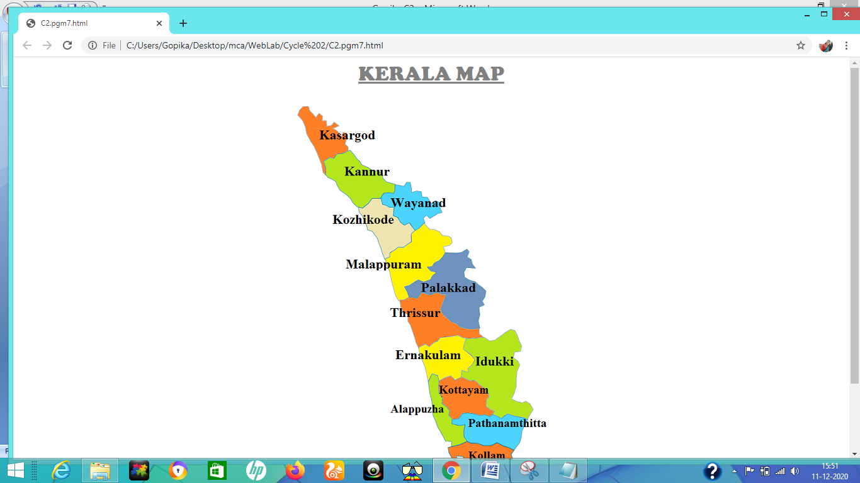

**Kottayam**

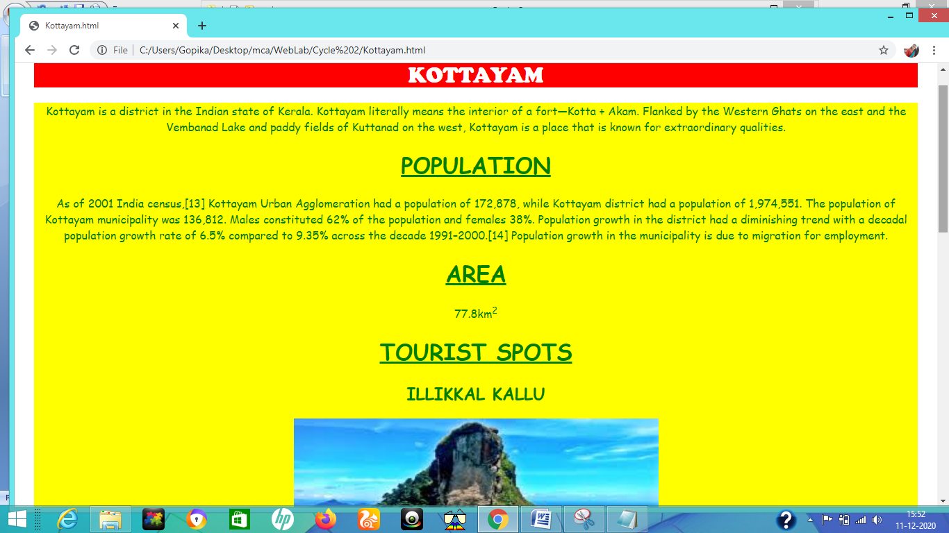

**Pathanamthitta**

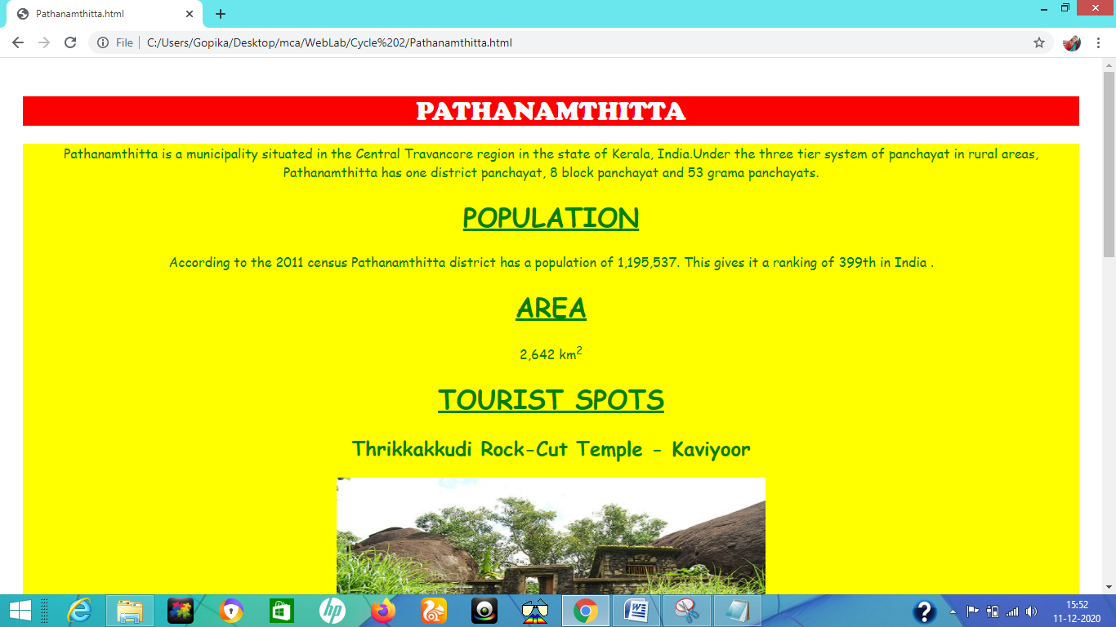

**Wayanad**

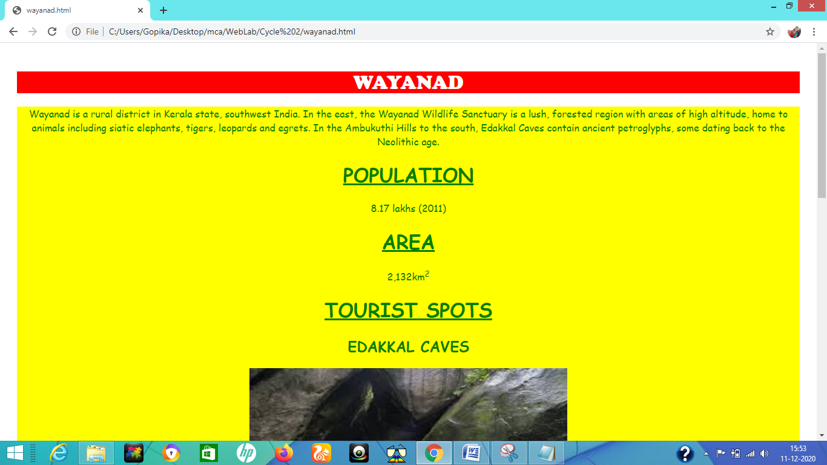

1. Construct this puzzle looking thing

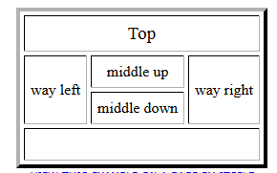

**Code:**

<html>

<head>

</head>

<body>

<br><br>

<table align="center" border="2" cellspacing="0">

<tr>

<th colspan="5">Top </th>

</tr>

<tr>

<th rowspan="2"> way left </th>

<th colspan="2"> middle up </th>

<th rowspan="2"> way right </th>

</tr>

<tr>

<th colspan="2"> middle down </th>

</tr>

<tr>

<th colspan="5"> &nbsp; </th>

</tr>

</table>

</center>

</body>

</html>

**Output:**

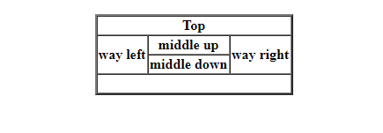

1. Make up three image links for 3 web browsers and put them in a borderless table. Construct the table so that there is just a little space between the images.

**Code:**

<html>

<head>

</head>

<body>

<br><br>

<table align="center" style="border-collapse : collapse;">

<tr>

<td> <a href="https://www.firefox.com/" target="_blank">

<img src="firefox.jpg" alt="firefox" height="220" width="220"/>

</td>

</tr>

<tr>

<td> <a href="https://www.google.com/chrome/" target="_blank">

<img src="google.jpg" alt="chrome" height="220" width="220"/>

</td>

</tr>

<tr>

<td> <a href="https://microsoft.com" target="_blank">

<img src="edge.jpg" alt="edge" height="220" width="220"/>

</td>

</tr>

</table>

</body>

</html>

**Output:**

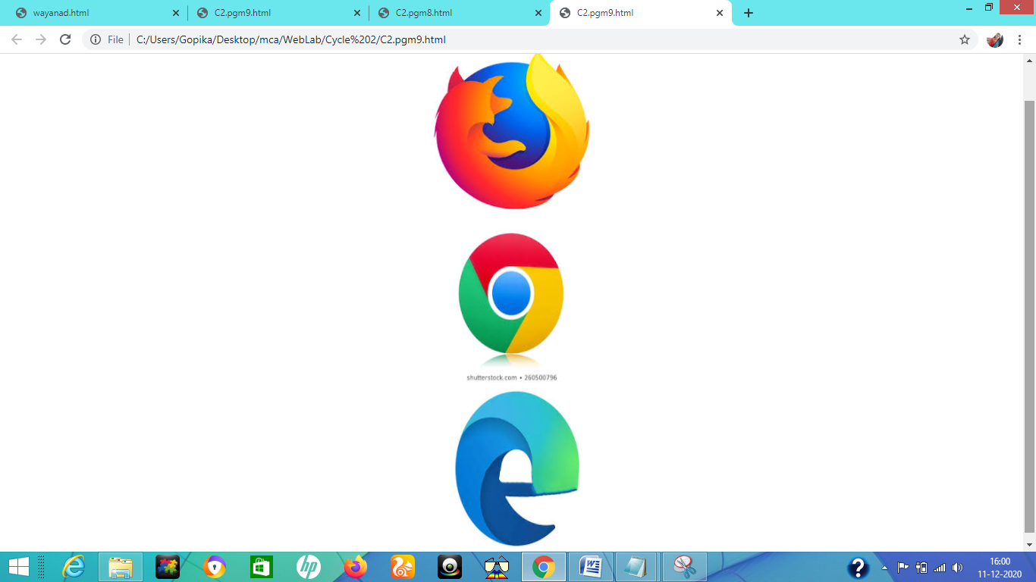

1. **Create the following html page using frames**

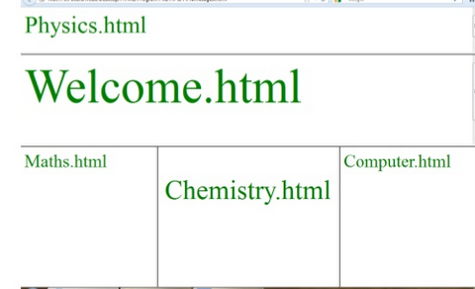

**Code:**

<html>

<head></head>

<frameset rows="20%,30%,*" border="6">

<frame src="Physics.html" name="Physics.html"/>

<frame src="Welcome.html" name="Welcome.html"/>

<frameset cols="25%,50%,*" frameborder="6">

<frame src="Maths.html" name="Maths.html"/>

<frame src="Chemistry.html" name="Chemistry.html"/>

<frame src="Computer.html" name="Computer.html"/>

</frameset>

</frameset>

</html>

**Chemistry.html:**

<html>

<head>

</head>

<body>

<br>

<h1><font color="green" size="6">Chemistry.html</font></h1>

</body>

</html>

**Maths.html**

<html>

<head>

</head>

<body>

<br>

<h1><font color="green" size="5">Maths.html</font></h1>

</body>

</html>

**Physics.html**

<html>

<head>

</head>

<body>

<br>

<h1><font color="green" size="6">Physics.html</font></h1>

</body>

</html>

**Computer.html**

<html>

<head>

</head>

<body>

<br>

<h1><font color="green" size="5">Computer.html</font></h1>

</body>

</html>

**Output:**

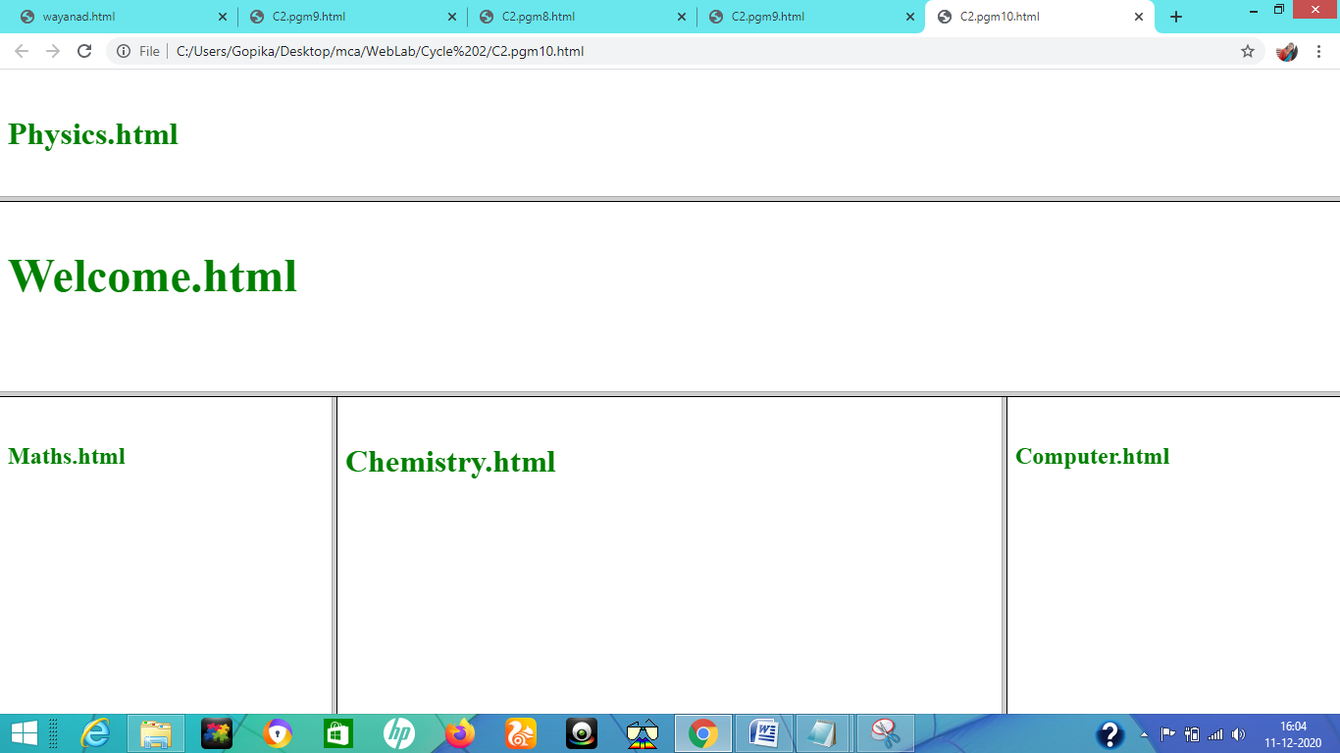

1. **Create an HTML page using frames which is similar to the following one.**

**In the left frame provide hyperlinks to 3 important monuments in world. On clicking that hyperlink an image of the monument should be displayed in right frame with suitable description**

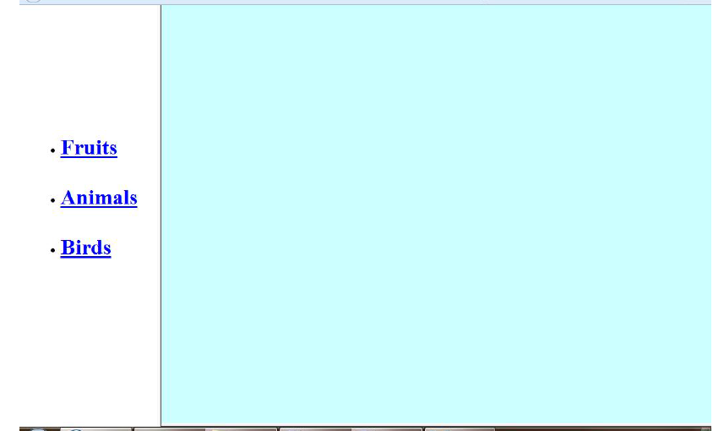

**Code:**

<html>

<head>

<title> Navigation </title>

</head>

<frameset cols="25%,*">

<frame src="link.html"/>

<frame src="home.html" name="z"/>

</frameset>

<body>

</body>

</html>

**Gol Gumbaz.html**

<html>

<head>

<style>

.div_1{ background-color:orange; margin:20px; }

.div_2{ background-color:yellow; margin:20px; }

</style>

</head>

<body>

<center>

<br>

<div class="div_1"><h1><font color="green" size="6" face="cooper">Gol Gumbaz</font></h1></div>

<div class="div_2">

<img src="Gol Gumbaz.jpg" alt="Gol Gumbaz" height="300" width="450"/>

<p style="text-align:left;">Gol Gumbaz is the mausoleum of king Muhammad Adil Shah, Adil Shah Dynasty. Construction of the tomb, located in Vijayapura, Karnataka, India, was started in 1626 and completed in 1656. The name is based on Gola gummata derived from Gol Gombadh meaning "circular dome".

It follows the style of Indo-Islamic architecture</p>

</div>

</body>

</html>

**Tajmahal.html**

<html>

<head>

<style>

.div_1{ background-color:orange; margin:20px; }

.div_2{ background-color:yellow; margin:20px; }

</style>

</head>

<body>

<center>

<br>

<div class="div_1"><h1><font color="green" size="6" face="cooper">TAJ MAHAL</font></h1></div>

<div class="div_2">

<img src="Tajmahal.jpg" alt="TAJMAHAL" height="300" width="450"/>

<p style="text-align:left;" >The Taj Mahal is an ivory-white marble mausoleum on the southern bank of the river Yamuna in the Indian city of Agra.It was commissioned in 1632

by the Mughal emperor Shah Jahan (reigned from 1628 to 1658) to house the tomb of his favourite wife, Mumtaz Mahal;it also houses the tomb of Shah Jahan himself.

The Taj Mahal attracts 7–8 million visitors a year and in 2007, it was declared a winner of the New 7 Wonders of the World (2000–2007) initiative.</p>

</div>

</body>

</html>

**Konark Sun Temple.html**

<html>

<head>

<style>

.div_1{ background-color:orange; margin:20px; }

.div_2{ background-color:yellow; margin:20px; }

</style>

</head>

<body>

<center>

<br>

<div class="div_1"><h1><font color="green" size="6" face="cooper">Konark Sun Temple</font></h1></div>

<div class="div_2">

<img src="konark.jpg" alt="Konark Sun Temple" height="300" width="450"/>

<p style="text-align:left;">Konark Sun Temple (Konark Surya Mandir) is a 13th-century CE Sun temple at Konark about 35 kilometres (22 mi) northeast from Puri on the coastline of Odisha, India.The temple is attributed to king Narasimhadeva I of the Eastern Ganga Dynasty about 1250 CE.</p>

</div>

</body>

</html>

**Output:**

